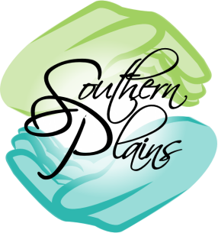Dialectical Behavior Therapy Services

Dialectical Behavior Therapy: is a cognitive behavioral treatment developed by Marsha Linehan, PhD, ABPP. It emphasizes individual psychotherapy and group skills training classes to help people learn and use new skills and strategies to develop a life that they experience as worth living. DBT skills include skills for mindfulness, emotion regulation, distress tolerance, and interpersonal effectiveness. (https://behavioraltech.org)

Who: Group leaders are Jennifer Bennett & Lindsey McCarthy
What: 6-month long adult DBT group. Required to be age 18 or above. Groups will run two hours long each week and times will depend upon participants’ schedules.
When: Starting January 2019
Where: Southern Plains Behavioral Health Services Office in Winner, SD.

Wanting to join? Call the Winner, SD office now to make a referral for yourself or others. You can also visit our website www.spbhs.net and go under the “Services” tab to print our referral form. This form can be faxed to the Winner, SD office or dropped off at the address below. Groups will remain open and Referrals can be made at any time before or during the 6-month duration of the groups.

Winner Office
Phone - (605) 842-1465
Fax - (605) 842-2366
Address -
500 E. 9th St.
Winner, SD 57580

